**Report milestone 2**

**Team 506 – Moon Knight**

1. **Functionalities should be done**

* Build basic database
* Design initial user interface for the client’s eveluation

+ Product management page interface design

+ Complete CRUD products (backend)

* Order management page interface design with basic functions

+ Fill information, view the products in cart.

* Complete the function of viewing and searching for product

1. **Functionalities that have been done**

* **Functionality: CRUD product**

+ Use case name: CRUD product

+ Description: As a store manager, I want to manage product in the system

+ Actor: Store manager

+ Trigger: Store manager want to manage product in the system

+ Pre-condition: Store manager signs in successfully

+ Post condition: Show product changes in the system

+ Basic flow:

1. Store manager sign in the system
2. Store manager view all product in the store

3. Store manager add/edit/delete product

4. The system confirms the successful operation

+ Alternative flow

3a. Store manager add product to system

3a1. Store manager enter all information of product

3a2. Store manager ask system to save changes

3b. Store manager edit product

3b1. Store manager choose information that he want to edit

3b2. Store manager edit the information

3b3. Store manager ask system to save changes

3c. Store manager delete product in the system

3c1. Store manager choose products that he want to delete

3c2. Store manager ask system to save changes

* **Functionality: Search product**

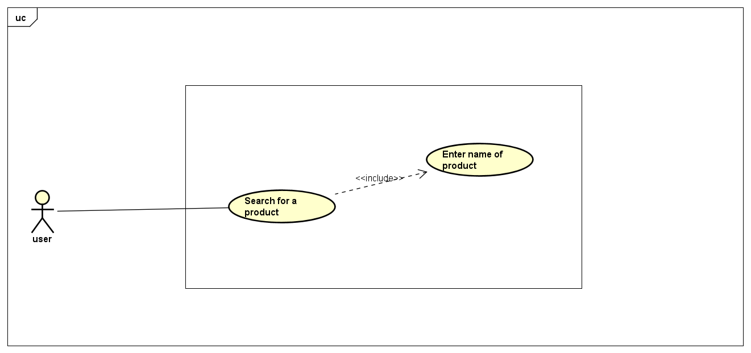

+ Use case name: Search for a product

+ Description: I am a user, I want to search for a product

+ Actor: User

+ Trigger: User access to the system

+ Pre-condition: None

+ Post condition: None

+ Basic flow:

1. User enter name of product which he want to search in store

2. System show the list of product related to the product that user searched

+ Alternative flow:

2a. System notifies that the product is not found and show a search bar for users to try again.

* **Functionality: Add a product to cart**

+ Use case name: Add product to cart

+ Description: As an user, I want to add product I like to my cart

+ Actor: User

+ Trigger: User access to the system

+ Pre-condition: User is in the “Show detail of product” part

+ Post condition: User can see product in his cart.

+ Basic flow:

1. User choose the product he want to buy
2. System get product information and then return product’s information page
3. User choose size
4. User choose number of product
5. User enter Buy button
6. System check if user has choose size
7. System checks the validity of the product quantity
8. System show notification “Order successfully”

+ Exception flow:

6a. System notifies error, ask user to choose size

7a. System notifies error, amount of product must be greater than and smaller or equal to the number of product available in stock

1. **Problems**

* There were 2 people in our team taking Covid 19 test, so the others had to make up for their work.
* Because of limited time in the week, we must host online meeting in the evening or at the weekend.